43.30: The activity of the sample is 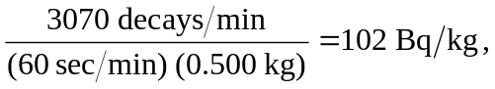 while the activity of atmospheric carbon is 255 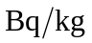 (see Example 43.9). The age of the sample is then
